Meta Description:
Do you want to master the true art of doing local keyword research? Read this guide and do local keyword research like a pro to make your brand a pro.

Mastering Local Keyword Research for SEO: A Comprehensive Guide


With the advancement of the digital world in the present day, Local SEO has proven itself to be an indispensable tool for many companies, desiring to serve their clients locally.
As recent statistics have shown, close to 93% of the consumers search for local businesses online before making a purchase decision.
Therefore, optimizing the search engine for local queries and keywords is no longer a necessity but mandatory.
Local SEO will assist your business to be easily found online, bring more traffic to a company’s physical location, and boost the brand within a specific geographical region.
Key Takeaways:
- A brief description of what local SEO keyword research includes and why it is relevant.
- The distinction between implicit and explicit local keywords.
- The procedures to use in carrying out a proper local keyword research.
- Several methods and actions useful in the discoverability of local keywords and how these can be prioritized.
- Explaining the concept of keyword mapping and the approach to use when optimizing for local SEO.

What Is Local SEO Keyword Research?
Local SEO keyword is the practical discovery of effective keywords or phrases that can be used by an SEO expert in targeting website visitors within a given geographical region.
It ranges from the study of potential customer behaviors within a delimited geographical area and selection of the most suitable terms concerning the customer needs and search purposes.
This research mainly focuses on increasing the ranking position of a business for sale so that it appears when customers are looking for similar products and services within their region.

Differentiating Between Implicit and Explicit Local Keywords:

Implicit Local Keywords: Understanding User Search Behavior:
Such inherent local keywords include general terms that are associated with local purpose with no reference to an area.
These keywords are used by users who are still within a broad category, or are seeking a more extensive location.
For example, a search query as “marketing agency near me” does not mean that the concrete city or district is indicated, but the user is interested in a marketing agency in their location.
These are essentially the terms of analysis of the search queries and user behavior that point to local intent without directly referring to any locality keyword.

Explicit Local Keywords: Targeting Specific Locations

Whereas, the direct local keywords point directly to a certain locality or a region. These keywords are employed by users who already possess geographic orientations on the areas they would wish to embark on.
For instance, ‘‘digital marketing services in Dubai’’ or ‘‘social media marketing Dubai’’ are categorized without a doubt as local keywords. By targeting local search keywords, the business will be in a position to capture users who are looking for such services or products nearest to their local region.

Steps for Conducting Effective Local Keyword Research:
Here are some game-changing steps you need to take if you want to conduct local keyword research effectively. Let’s have a look at what you need to do to make your research more effective:
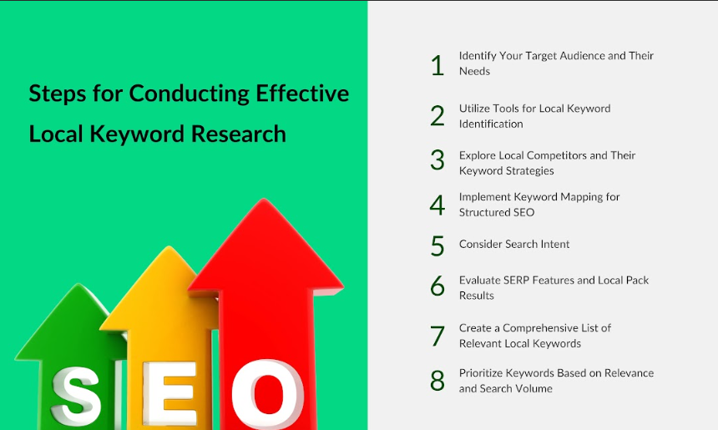

Identify Your Target Audience and Their Needs:
The first process in the keyword research is the identification of the intended audience. In the process of creating and developing your social media presence, it is crucial to know who your target audience is, what their characteristics are and the problems they face.
It will help you to determine the keywords that are familiar to them. Such factors include age, gender, income level, and lifestyle. This should be done in order to ensure the keyword matches that of your target audience in the market.

Utilize Tools for Local Keyword Identification:
To look for local keywords, you can use some tools like Google Keyword Planner, SEM rush, Ahrefs, and Moz. Such Internet marketing tools tend to bring information on keywords, their average monthly search and competition.
Moreover, you can also filter such keywords on the basis of location, making it easy to find the keyword that applies to a certain region. This way, you can develop a list of local keywords to research their strength.

Explore Local Competitors and Their Keyword Strategies:
The key aspects of analyzing the keywords are through competitor analysis on the local level. Look for companies that are placed well in local search engine results and check the keywords they use.
You can use SEMrush and Ahref tools to look at the keywords relating to competitors’ websites. Such tools will assist you in identifying your own blind spots and to learn where else you can get more local search traffic.

Implement Keyword Mapping for Structured SEO:
Keyword mapping means providing every page of your site with specific keywords that are relevant to it. This way, each page is effectively aligned to the most effective keywords to optimize the SEO plan.
In the local SEO context, keyword mapping involves the local relevance aspect of every keyword. Make sure local keywords should be matched with the pages in the local markets, including service pages, localized destination/site pages or blog posts on relevant events and topics.

Search Intent: Failure and Success in Keyword Pagination
In your Keyword choice for local search needs, you should consider the intent of the users properly. Search intent, also known as search motive, is the real purpose that the user is serving with his/her search query.
With proper keyword mapping, you can target your audience with the right keywords to achieve your goals and address your needs. For instance, a user that types “digital marketing agency near me in Dubai” is going to be in dire need of digital marketing agency services. You can use these different intents to refine your content and keywords.

Evaluate SERP Features and Local Pack Results:
SERPs consist of local packages, reviews, and other maps that are very important in local SEO. To optimize your SERP features’ visibility, analyze the SERP features dedicated to your targeted local keywords.
To increase your chance of being placed in these features, make sure that your business information is up to date, complete, and consistent in your listings on services such as Google My Business, Yelp, and TripAdvisor.

Create a Comprehensive List of Relevant Local Keywords:
Create a list of local keywords of interest that can be used based on the research done. By targeting the most relevant keywords, you can easily achieve the goals of your business with ease. This list includes both implied and, at the same time, direct local keywords on various topics concerning both broad and specific keywords.
Use keyword ranking in order of relevance, and popularity. However, competitiveness is an important parameter that should not be ignored. Also, to help you to create content and optimize your pages, use this list containing important local keywords.

Prioritize Keywords Based on Relevance and Search Volume:
Before selecting a clear list of local keywords, it is advisable to filter the keywords based on their relevance to your business and how often people search them up.
Avoid keywords that have very little relevance to your products or services, but at the same time, do not target any ‘high’ difficulty keyword. It is not advisable to opt for those keywords that are closely contested as this will require a lot of effort in the marketing campaign.
Create a balance between opting for highly competitive keywords and long-tail terms that are still relevant within the locals’ radar, to get a broad range of clientele.

Manage Local SEO Across Multiple Locations
You could take into consideration all the locations where your business is currently operating. Make sure your GMB includes both locations without any kind of error. Here is what you can consider to manage your Local SEO for multiple locations:

Establish a Hierarchical Structure for Different Locations:
When choosing the layout of the locations, making them in a hierarchical order in the hierarchy of importance. This involves the company’s websites and subdomains ordering based on the regions they cater for. The clearly defined structure of subcategories allows search engines to identify the connection to the site’s overall and particular location pages.
Consider using a structure like:
- Main website (e.g., www.yourbusiness.com)
- Location 1 (e.g., www.yourbusiness.com/location1)
- Location 2 (e.g., www.yourbusiness.com/location2)
This not only benefits search engine crawlers, but makes it easier for the user to find what you want to have under your stream of products.

Customize Content to Meet Local Demographics and Culture:
Local SEO is not just adding a city name into the keyword lists. This is due to the fact that each place has its own population group, so their peculiarities have to be taken into consideration.
It is also important to investigate matters of local interest and activities, as well as other factors that may make people from that area connect to the content published in the newspaper.
This can include posts related to local events, news articles and guides featuring the local attractions.

Partner with Local Influencers for Enhanced Reach:
Working with the local social media influencers is much effective when it comes to gaining coverage and trust.
You know very well that followers have placed their trust in the influencers and such recommendations can help your business to have more traffic and a higher conversion rate.
You can approach those influencers whose audiences fall in line with your target market, approach them for partnership in any campaign that would popularize your business. You can opt for sponsorship, doing collaborative accounts or campaigns, or pop-up events.

Leverage Backlinks from Local Businesses and Organizations:
Local business referrals from other serious organizations will help you to strengthen your site’s authority and increase the ranking on local search results.
You can contact partners, vendors, businesses whose services or products are related to yours, or potential community partners, to get backlinks.
Gain publicity through local activities, sponsorships, or partnerships to get the attention of local webmasters for improving local SEO.

Maintain Consistency Across Google Business Profiles for Each Location:
There are several rules for the effective management and to Optimize Google Business Profile for more than one site. Make sure each profile is completed with complete information such as an address, phone number, business hours, and category.
Brand identity in multiple profiles is a great way to gain trust from the users, and improve SERP ranking of your business in local search.
It is also important to check the completeness of the profiles and edit the given information if there is any change in the business.

How to Monitor Your Local Keyword Rankings:?
Make sure to check your Local SEO needs regularly, with key phrases or keywords used in your site. Some of the standard and effective ways of measuring and monitoring the keyword ranking in a given locality are what we will discuss in great detail here:
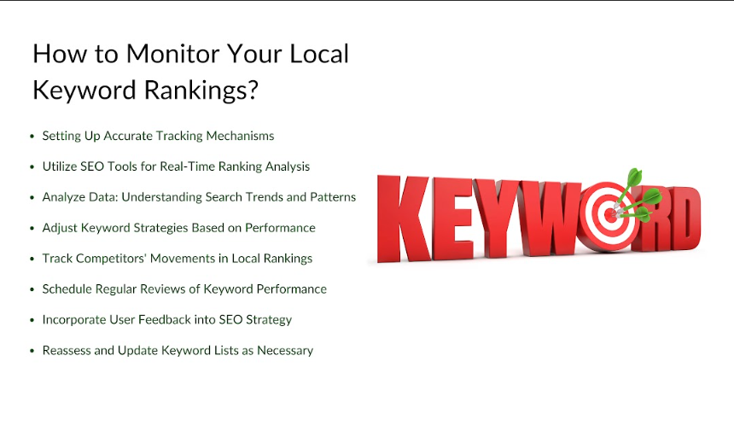

Setting Up Accurate Tracking Mechanisms:
To track your local keyword correctly, ensure you put in place good tracking mechanisms. You can use Google Search Console and Google Analytics to know the impressions, click through rate (CTR), and conversions on the desired local keywords that can be used for optimization.
By conducting Regional Analysis Tracking of your website, you can understand how your site is doing on the local level.

Utilize SEO Tools for Real-Time Ranking Analysis:
It is advisable to analyze ranking in order to incorporate real-time SEO tools to capture ranking on any given local keyword.
It is possible to use different tools like SEMrush, Ahrefs or Moz for tracking the keyword rankings, the search volume and the competition.
Additionally, you can also check these tools from time to time as this will help in detecting some patterns and possibly improvement areas.

Analyze Data to Determine Search Trends:
The analysis of data is highly relevant in order to gain insight into the specifics of search engine trends.
Check the data from the tracking tools and find out which local keywords give traffic or conversion.
Identify regular fluctuations over time in the type of search queries performed by the users and post relevant content in accordance with such variations.

Adjust Keyword Strategies Based on Performance:
Make changes to all the keywords according to the results you have obtained as part of your data analysis.
If there are some keywords with low popularity, it is recommended to refine the content or optimize on-page factors or target other keywords.
It’s crucial that you update your SEO activities to optimize for your localized sites with regards to the current trends as well as the needs of the users.

Track Competitors' Movements in Local Rankings:
Try to track your competitors’ positions in the local listings as well. This will involve analyzing the keywords they are targeting, the content they are providing, and the backlinks they possess for the purpose of coming up with a development plan.
Try to apply this information to improve your strategy and dominate the local search rankings.

Schedule Regular Reviews of Keyword Performance:
It is crucial that the performance of local keywords is checked frequently to have a proper local SEO strategy.
It is advised to make regular check-ups at least monthly or quarterly to cross-check your progress, analyze your weaknesses or improvement, and modify your plans consequently.
This way you can be in a position to know how your SEO strategies are complementary to your business goals and objectives.

Incorporating User Feedback into SEO Strategy:
User engagement offers insightful information concerning the performance of your local SEO.
You should convince your clients to leave reviews for your business on sites such as Google My Business and Yelp.
It is now possible to use your clients' feedback to boost your local content and to fill any local SEO gaps that you may currently have.

Reassess and Update Keyword Lists as Necessary:
The local search trends might also vary and it is very necessary to upgrade the keyword list from time to time.
Be up-to-date about the occurrences and tendencies that may influence people’s searches on the web in the given region.
This way, it is possible for the keyword list to be refined continuously to make it more relevant as well as effective in driving traffic local to your site.

Strategies to Enhance Local Visibility:
Local visibility is not a single value that could be easily changed by some marketing decision, but rather an umbrella term for a complex of factors. Some of the possible strategies to enhance the overall visibility level of your brand on the local level are:

Optimize Your Google Business Profile for Maximum Exposure:
It is strategic for your business to have an optimized GMB as it can be a free source of backlinks for your websites. This can also be a factor that shapes people’s first impressions of your company, as often you are referred on the web through your business listing.

Tips for Optimizing Your Google Business Profile

- Fill All Sections: Make sure all the information you are giving about the business, like the business name, its location, phone number, as well as the website, is correct.
- Keyword Targeting: Local keywords should be incorporated in the profile, especially in the business description and services offered.
- Add High-Quality Photos: Appearance counts so make sure you add high-quality photos in your GMB. It is wise to do this from time to time to keep the profile more interesting to the visitors.
- Promote Reviews: Positive reviews can not only enhance the ranking of the profile but also its popularity. Receiving reviews is considered a positive sign. Make sure you take time to read the responses other consumers have given and show appreciation with a view of encouraging the active consumer to purchase the product.
- Post Any Changes: Offer an opportunity to share new promotions or announcements with the customers. This ensures that your profile is readily noticeable and active with the potential customers.

Create Location-Specific Content that Resonates with Local Audiences:
The content is the king and when you incorporate location-specific content, then you are sure to get great results in your local market. This way you can gain some authority and the trust of your potential customers within your target region.
Here are some strategies you can follow to create localized content for your brand:
- Assist in writing about Local Activities and Events: Writing about local activities and events helps one to have more hits in the local searches.
- Add Introductory Information: Local information can be valuable and may include guides suitable for a specific area or how to do something such as plumbing, wiring, etc.
- Emphasize customer references: It is important to provide success stories or experiences from customers within the area.
- Local Keywords Implementation: It is important that your blog posts contain a lot of relevant local keywords to increase their search engine rankings.

Utilize Social Media Channels for Local Engagement:
Social media networks are innovative methods in communication with the target locality. You can rely on social channels for posting location-based content, engaging with users and followers, and advertising promotions.

Generate and Encourage Online Reviews for Credibility:
The evaluations of your products and services over the internet are a significant feature of local SEO. Ask those who have opted to fully pay for either the products that your business sells or your services to leave good comments on Google, Yelp, and Facebook. Always be quick to respond to any negative comment you receive professionally.

Collaborate with Local Businesses to Create Joint Marketing Initiatives:
Sourcing other local businesses like you makes it possible to increase the customer base in the local market. Ideally, try to apply for cross-promotions or perhaps hold joint events or post similar content to also help bring in each other's clientele.

Ending Note:
Keyword research is one of those crucial areas of skills in an organization, regardless of the scale of business practicing E-Business. With these strategies adopted from this guide, you will increase your local presence and get more locals to come to your site and boost your search ranking.
For further information about local SEO and marketing, please visit Three Angle Marketing (TAM). At TAM we are committed to assisting the Dubai businesses to reach their marketing objectives and to thrive in the digital space. So, take a look at the details of services that we offer and contact us to learn how to tackle local SEO.

